SECTION A – ENTITY RELATIONSHIP DIAGRAM (ERD)
1. System Overview
The RaceDay system is designed to manage sporting or racing events. The system allows users to register and log in, maintain their profiles, organise events, create race categories, enrol participants into categories and record race results.
The database contains the following six core entities:
- Roles
- Users
- Events
- Categories
- EventEnrollments
- Results

2. Entity Relationship Diagram
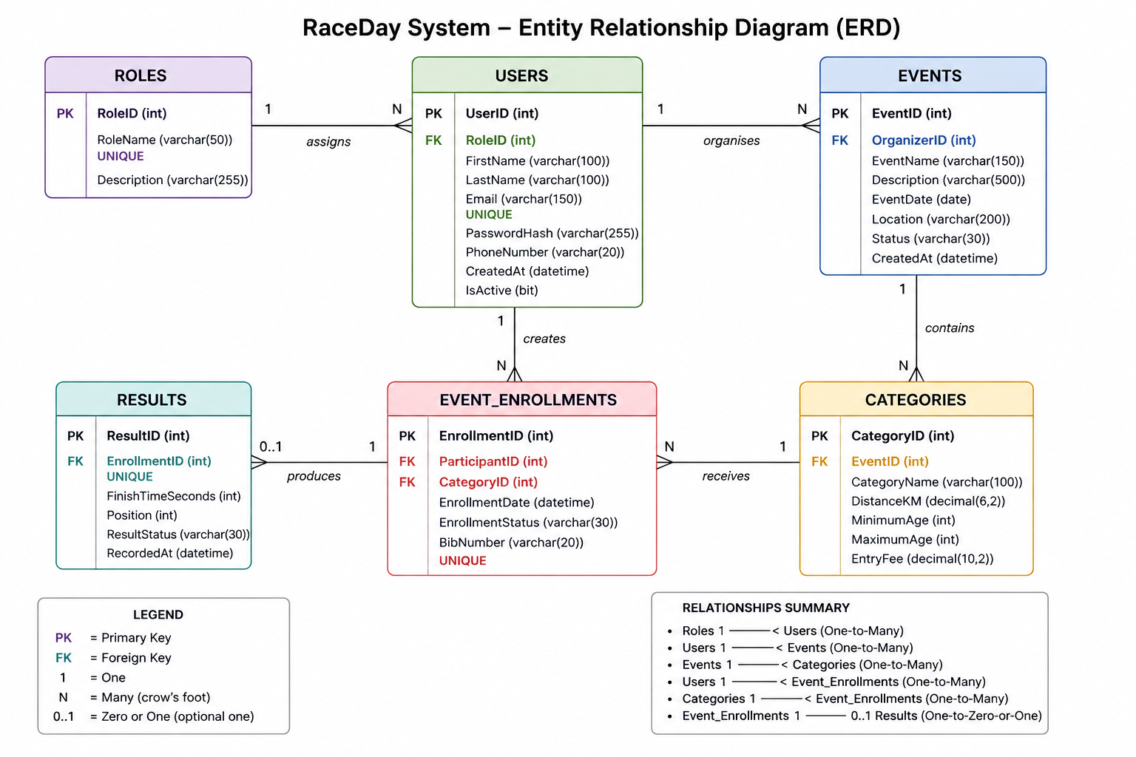

3. Entity Descriptions
3.1 Roles
The Roles entity stores the different types of users within the RaceDay system.
Attribute | Data Type | Key/Constraint | Description
RoleID | INT | Primary Key | Unique identifier for each role
RoleName | VARCHAR(50) | UNIQUE, NOT NULL | Name of the role
Description | VARCHAR(255) | NULL | Description of the role
Example roles
- Administrator
- Organizer
- Participant

3.2 Users
The Users entity stores information about all users registered in the RaceDay system.
Attribute | Data Type | Key/Constraint | Description
UserID | INT | Primary Key | Unique user identifier
RoleID | INT | Foreign Key | Links the user to a role
FirstName | VARCHAR(100) | NOT NULL | User's first name
LastName | VARCHAR(100) | NOT NULL | User's surname
Email | VARCHAR(150) | UNIQUE, NOT NULL | User's email address
PasswordHash | VARCHAR(255) | NOT NULL | Securely stored password hash
PhoneNumber | VARCHAR(20) | NULL | User contact number
CreatedAt | DATETIME | DEFAULT | Date and time account was created
IsActive | BIT | DEFAULT | Indicates whether account is active

3.3 Events
The Events entity stores information about races created by organisers.
Attribute | Data Type | Key/Constraint | Description
EventID | INT | Primary Key | Unique event identifier
OrganizerID | INT | Foreign Key | User who created the event
EventName | VARCHAR(150) | NOT NULL | Name of the event
Description | VARCHAR(500) | NULL | Event description
EventDate | DATE | NOT NULL | Date of the event
Location | VARCHAR(200) | NOT NULL | Event location
Status | VARCHAR(30) | DEFAULT | Event status
CreatedAt | DATETIME | DEFAULT | Date created

3.4 Categories
Each event can contain multiple race categories.
Examples include:
- 5 km
- 10 km
- Half Marathon
- Full Marathon
Attribute | Data Type | Key/Constraint | Description
CategoryID | INT | Primary Key | Unique category identifier
EventID | INT | Foreign Key | Event to which category belongs
CategoryName | VARCHAR(100) | NOT NULL | Category name
DistanceKM | DECIMAL(6,2) | NOT NULL | Race distance
MinimumAge | INT | NOT NULL | Minimum participant age
MaximumAge | INT | NULL | Maximum participant age
EntryFee | DECIMAL(10,2) | DEFAULT | Cost of entering category

3.5 EventEnrollments
The EventEnrollments entity connects participants to race categories.
This entity resolves the relationship between:
Users (Participants) and Categories.
Attribute | Data Type | Key/Constraint | Description
EnrollmentID | INT | Primary Key | Unique enrolment identifier
ParticipantID | INT | Foreign Key | Participant who enrolled
CategoryID | INT | Foreign Key | Category selected
EnrollmentDate | DATETIME | DEFAULT | Date of enrolment
EnrollmentStatus | VARCHAR(30) | DEFAULT | Current enrolment status
BibNumber | VARCHAR(20) | UNIQUE | Race bib number

3.6 Results
The Results entity stores the final performance information for participants.
Attribute | Data Type | Key/Constraint | Description
ResultID | INT | Primary Key | Unique result identifier
EnrollmentID | INT | Foreign Key, UNIQUE | Links result to an enrolment
FinishTimeSeconds | INT | NULL | Race completion time in seconds
Position | INT | NULL | Final participant position
ResultStatus | VARCHAR(30) | DEFAULT | Finished, DNF, Disqualified
RecordedAt | DATETIME | DEFAULT | Date result was recorded

4. Relationships and Cardinality
Relationship | Cardinality | Explanation
Roles → Users | One-to-Many | One role can be assigned to many users
Users → Events | One-to-Many | One organiser can create many events
Events → Categories | One-to-Many | One event can contain many categories
Users → EventEnrollments | One-to-Many | One participant can have many enrolments
Categories → EventEnrollments | One-to-Many | One category can have many participants
EventEnrollments → Results | One-to-Zero-or-One | An enrolment may have zero or one result
Important Many-to-Many Relationship
Participants and Categories have a logical many-to-many relationship:
Participant
|
| One-to-Many
|
EventEnrollment
|
| Many-to-One
|
Category
A participant can enrol in multiple categories, while a category can contain multiple participants. The EventEnrollments entity resolves this many-to-many relationship.

SECTION B – API ENDPOINT PLAN
API Base Route
/api
All endpoints follow RESTful design principles.

1. Authentication Endpoints
HTTP Method | Route | Description | Role Required | Request Body | Expected Response
POST | /api/auth/register | Registers a new user account | Public | FirstName, LastName, Email, Password, PhoneNumber, RoleID | 201 Created – User account created
POST | /api/auth/login | Authenticates a registered user | Public | Email, Password | 200 OK – Authentication token returned
POST | /api/auth/logout | Logs out the current user | Any logged-in user | None | 200 OK – Successfully logged out
2. User Profile Endpoints
HTTP Method | Route | Description | Role Required | Request Body | Expected Response
GET | /api/users/profile | Returns the current user's profile | Any logged-in user | None | 200 OK – User profile
PUT | /api/users/profile | Updates the current user's profile | Any logged-in user | FirstName, LastName, PhoneNumber | 200 OK – Profile updated
GET | /api/users/{id} | Returns a specific user's information | Administrator | None | 200 OK – User details
GET | /api/users | Returns all registered users | Administrator | None | 200 OK – List of users
PUT | /api/users/{id}/status | Activates or deactivates a user | Administrator | IsActive | 200 OK – Status updated
3. Event Endpoints
HTTP Method | Route | Description | Role Required | Request Body | Expected Response
GET | /api/events | Returns all events | Public | None | 200 OK – Event list
GET | /api/events/{id} | Returns one event | Public | None | 200 OK – Event details
POST | /api/events | Creates a new event | Organizer | EventName, Description, EventDate, Location | 201 Created – Event created
PUT | /api/events/{id} | Updates an event | Event Organizer | EventName, Description, EventDate, Location, Status | 200 OK – Event updated
DELETE | /api/events/{id} | Deletes an event | Event Organizer or Administrator | None | 204 No Content – Event deleted
GET | /api/events/my-events | Returns events created by the logged-in organiser | Organizer | None | 200 OK – Event list
4. Category Endpoints
HTTP Method | Route | Description | Role Required | Request Body | Expected Response
GET | /api/events/{eventId}/categories | Returns all categories for an event | Public | None | 200 OK – Category list
GET | /api/categories/{id} | Returns a specific category | Public | None | 200 OK – Category details
POST | /api/events/{eventId}/categories | Creates a category for an event | Event Organizer | CategoryName, DistanceKM, MinimumAge, MaximumAge, EntryFee | 201 Created – Category created
PUT | /api/categories/{id} | Updates a category | Event Organizer | Category details | 200 OK – Category updated
DELETE | /api/categories/{id} | Deletes a category | Event Organizer or Administrator | None | 204 No Content – Category deleted

5. Event Enrolment Endpoints
HTTP Method | Route | Description | Role Required | Request Body | Expected Response
POST | /api/enrollments | Enrols a participant in a category | Participant | CategoryID | 201 Created – Enrolment created
GET | /api/enrollments/my-enrollments | Returns the current participant's enrolments | Participant | None | 200 OK – Enrolment list
GET | /api/events/{eventId}/enrollments | Returns enrolments for an event | Event Organizer or Administrator | None | 200 OK – Participant enrolments
GET | /api/enrollments/{id} | Returns a specific enrolment | Participant, Organizer or Administrator | None | 200 OK – Enrolment details
PUT | /api/enrollments/{id} | Updates enrolment status | Participant or Organizer | EnrollmentStatus | 200 OK – Enrolment updated
DELETE | /api/enrollments/{id} | Cancels an enrolment | Participant or Administrator | None | 204 No Content – Enrolment cancelled

6. Results Endpoints
HTTP Method | Route | Description | Role Required | Request Body | Expected Response
GET | /api/results | Returns all available results | Public | None | 200 OK – Results list
GET | /api/results/{id} | Returns a specific result | Public | None | 200 OK – Result details
GET | /api/events/{eventId}/results | Returns results for an event | Public | None | 200 OK – Event results
POST | /api/results | Records a participant result | Event Organizer or Administrator | EnrollmentID, FinishTimeSeconds, Position, ResultStatus | 201 Created – Result recorded
PUT | /api/results/{id} | Updates a result | Event Organizer or Administrator | Result details | 200 OK – Result updated
DELETE | /api/results/{id} | Removes a result | Administrator | None | 204 No Content – Result deleted

7. HTTP Status Codes
The RaceDay API will use the following standard HTTP status codes:
Status Code | Meaning
200 | OK – Request successful
201 | Created – New resource successfully created
204 | No Content – Resource successfully deleted
400 | Bad Request – Invalid request data
401 | Unauthorized – User not authenticated
403 | Forbidden – User does not have permission
404 | Not Found – Resource does not exist
409 | Conflict – Duplicate or conflicting data
500 | Internal Server Error – Unexpected server error

